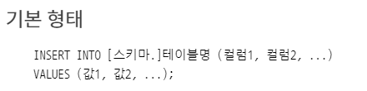

|  |  |
| --- | --- |
| INSERT | |
|  |  |

|  |  |
| --- | --- |
| INSERT | |
|  |  |
|  |  |
|  | |

**기본 형태**

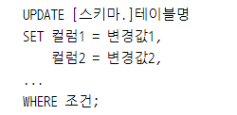

|  |  |
| --- | --- |
| UPDATE | |
|  |  |

|  |  |
| --- | --- |
| MERGE | |
|  |  |

|  |  |
| --- | --- |
| DELETE | |
|  |  |

|  |  |
| --- | --- |
| COMMIT , ROLLBACK, TRUNCATE | |
|  | |
|  | |
|  |  |

|  |
| --- |
| 연산자 |
|  |
|  |

